**Topic: Similar triangles and scale/ratio**

Time: 45 mins Marks: /45 marks

**No calculator allowed**



**Question One: [3, 4: 7 marks]**

a) The figures below are similar.



The surface area of the smaller cylinder is 25 mm2. What is the surface area of the larger cylinder?

b) The prisms below are similar.

The volume of the larger prism is 800 m3. What is the volume of the smaller prism?

**Question Two: [2, 2, 2: 6 marks]**

For the following sets of triangles, determine whether or not they are similar and justify your answer with a reason.

a)

****b)

c)



**Question Three: [3, 5: 8 marks]**

For each of the following:

i) State the reason for similarity.

ii) Calculate the value of the unknown variable.

a)

b)

**Question Four: [2, 4; 6 marks]**

This is a scale drawing of the floor plan of the office from NBC’s hit TV show The Office.

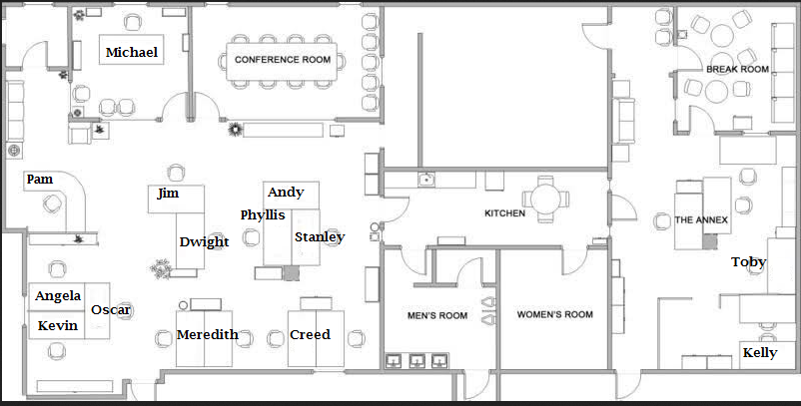

Scale: 1 : 100

a) What are the actual dimensions of Michael’s office, in metres?

b) If Toby goes to speak to Michael and walks via the kitchen, what is the approximate real life distance that he walks (to the nearest metre).

**Question 5: [6 marks]**

The following prism is enlarged such that the size of the smaller to the larger is in the ratio 1:4. Calculate the volume of the large prism, in m3.



**Question Six: [2, 4: 6 marks]**

These two images are similar.

a) Determine the scale factor for enlargement.

b) Use the scale factor to determine the area of the shaded face on the larger building.

**Question Seven: [6 marks]**

Find the three sets of similar triangles from the triangles below and for each set state the reason for similarity.

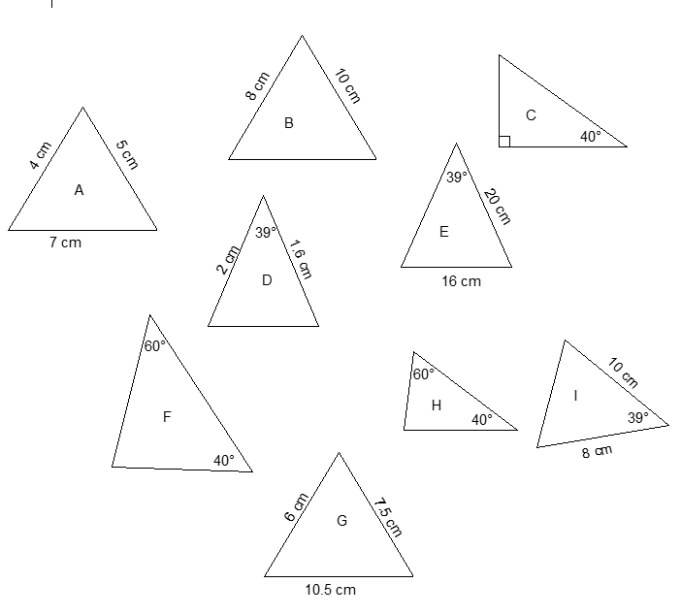

**Similar triangles and scale/ratio SOLUTIONS**

Time: 45 mins Marks: /45 marks

**No calculator allowed**



**Question One: [3, 4: 7 marks]**

a) The figures below are similar.



The surface area of the smaller cylinder is 25 mm2. What is the surface area of the larger cylinder?

b) The prisms below are similar.







The volume of the larger prism is 800 m3. What is the volume of the smaller prism?

**Question Two: [2, 2, 2: 6 marks]**

For the following sets of triangles, determine whether or not they are similar and justify your answer with a reason.

a)



Yes by AAA

****b)



Yes by AAA

c)

 Yes by SSS

**Question Three: [3, 5: 8 marks]**

For each of the following:

i) State the reason for similarity.

ii) Calculate the value of the unknown variable.

a)



 i) AAA

 ii) $\frac{10}{x+10}=\frac{20}{40}$



$x=10$

b)



$$\frac{6}{15}=\frac{7}{17.5}=\frac{2}{5}$$

i) SSS

ii) $8×\frac{2}{5}=2x+9$



$$20=2x+9$$

$2x=11$

$x=5.5$

**Question Four: [2, 4; 6 marks]**

This is a scale drawing of the floor plan of the office from NBC’s hit TV show The Office.



Scale: 1 : 100

a) What are the actual dimensions of Michael’s office, in metres?

 2.2 cm by 2.2 cm

220 cm by 220 cm $∴$ 2.2 m by 2.2 m

b) If Toby goes to speak to Michael and walks via the kitchen, what is the approximate real life distance that he walks (to the nearest metre).





**Question 5: [6 marks]**

The following prism is enlarged such that the size of the smaller to the larger is in the ratio 1:4. Calculate the volume of the large prism, in m3.









**Question Six: [2, 4: 6 marks]**

These two images are similar.



a) Determine the scale factor for enlargement.

 2

b) Use the scale factor to determine the area of the shaded face on the larger building.





$Area of snaller=15×12+\frac{15×6}{2}$

$$=180+45$$

$$=225 {cm}^{2}$$

$$Area of larger=Area of smaller ×2^{2}$$

$$=224×4=900 {cm}^{2}$$

**Question Seven: [6 marks]**

Find the three sets of similar triangles from the triangles below and for each set state the reason for similarity.







